**FORMAN CHRISTIAN COLLEGE**

**(A CHARTERED UNIVERSITY)**



**Embedded Systems (CSCS 306)**

**FALL-2019**

**LAB-09**

**Ubuntu Server CRUD**

**Group Members:**

* Mohammad Usman 20-10558
* Abeer Butt 20-10596
* Haris Naseer 20-10612

**Introduction:**

The aim of the lab was to test our skills in dealing with Ubuntu Server machine and connecting it with another Linux Machine, both running on VirtualBox. This lab consists of three LabTasks.

**LabTask1:** In this LabTask, we created a database on Mysql server installed on the Ubuntu Server machine and created a table that had 4 fields (id, firstName, lastName, age). Then, we inserted and deleted records from the table using different insert and delete queries.

**Working Code:**

create database labexamdb;

use labexamdb;

create table tb (

id int unsigned auto_increment primary key,

firstName varchar(256) not null,

lastName varchar(256) not null,

age int unsigned not null

);

insert into tb (firstName, lastName, age) values (‘Ali’, ‘Butt’, 21);

insert into tb (firstName, lastName, age) values (‘Adil’, ‘Khan’, 20);

delete from tb where firstName = ‘Ali’;

delete from tb where id = ‘2’;

**Running Program Screenshots:**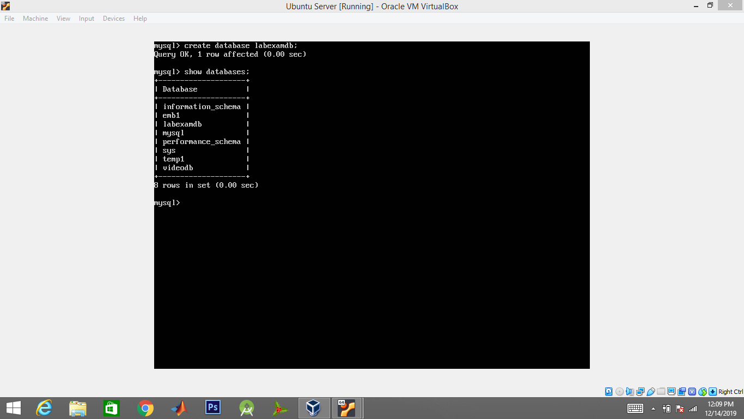

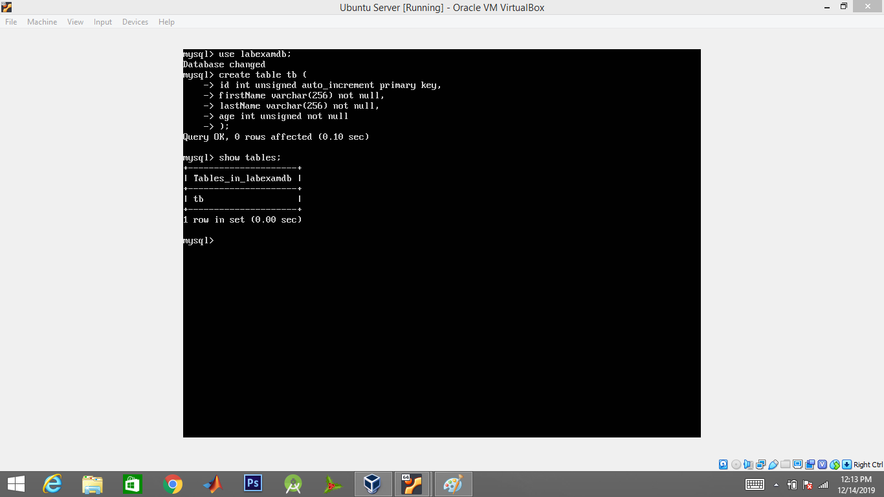

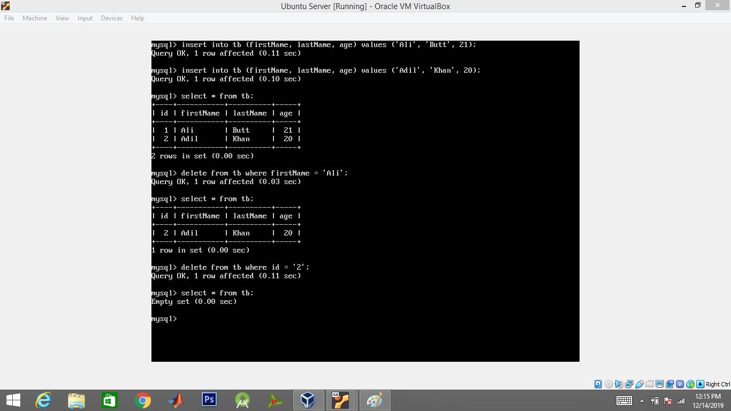

**LabTask2:** In this LabTask, we created three php files (insert.php, delte.php, update.php) and placed them in /var/www/html directory in the Ubuntu Server machine. We added and deleted records by forming the appropriate links on the address bar of a web browser. We had to use the same database and table created in LabTask1.

**Working Code:**

**insert.php**

<?php

$servername = "localhost”;

$username = 'root';

$password = '123456';

$dbname = 'labexamdb';

// Create connection

$conn = new mysqli($servername, $username, $password, $dbname);

// Check connection

if ($conn->connect_error) {

die("Connection failed: " . $conn->connect_error);

}

$firstName = $_GET["firstName"];

$lastName = $_GET["lastName"];

$age = $_GET["age"];

$sql = "INSERT INTO tb (firstName, lastName, age)

VALUES ('$firstName', '$lastName', '$age')";

if ($conn->query($sql) === TRUE)

{

echo "New record created successfully";

}

else

{

echo "Error: " . $sql . "<br>" . $conn->error;

}

$conn->close();

?>

**delete.php**

<?php

$servername = "localhost”;

$username = 'root';

$password = '123456';

$dbname = 'labexamdb';

// Create connection

$conn = new mysqli($servername, $username, $password, $dbname);

// Check connection

if ($conn->connect_error) {

die("Connection failed: " . $conn->connect_error);

}

$firstName = $_GET["firstName"];

$sql = "DELETE FROM tb WHERE firstName = $firstName";

if ($conn->query($sql) == TRUE)

{

echo "Record deleted successfully";

}

else

{

echo "Error: " . $sql . "<br>" . $conn->error;

}

$conn->close();

?>

**update.php**

<?php

$servername = "localhost”;

$username = 'root';

$password = '123456';

$dbname = 'labexamdb';

// Create connection

$conn = new mysqli($servername, $username, $password, $dbname);

// Check connection

if ($conn->connect_error) {

die("Connection failed: " . $conn->connect_error);

}

$id = $_GET["id"];

$firstName = $_GET["firstName"];

$sql = "UPDATE tb SET firstName = '$firstName' WHERE id = $id";

if ($conn->query($sql) == TRUE)

{

echo "Record updated successfully";

}

else

{

echo "Error: " . $sql . "<br>" . $conn->error;

}

$conn->close();

?>

**Running Program Screenshots:**

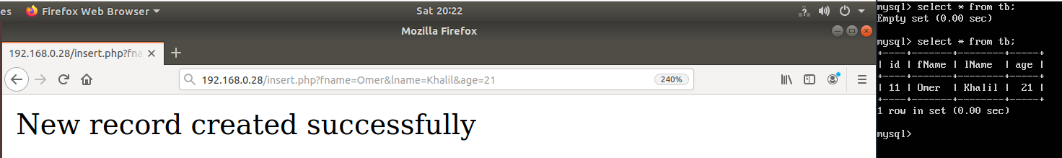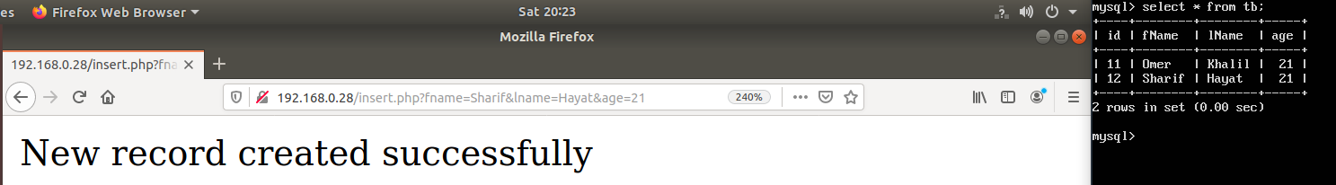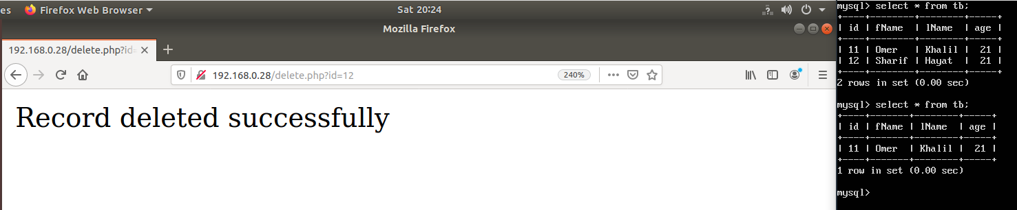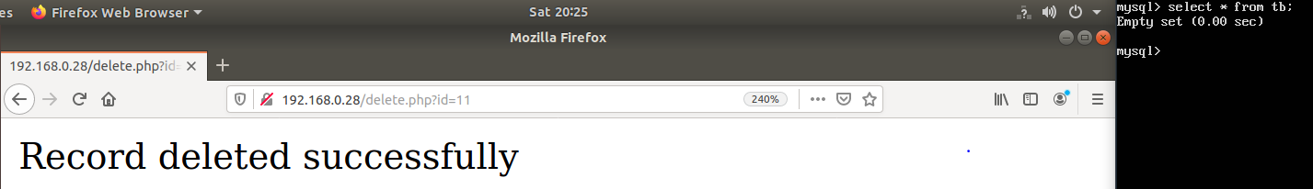

**LabTask3:** In this LabTask, we created a simple html page containing three text boxes for First Name, Last Name, Age and an Insert button. On click of Insert button, the information entered on the fields is stored in the table created in LabTask1. We also added html code for handling the deletion of records. The html code contains one field for entering First Name and a Delete button. On click of Delete button, the record with the same First Name as entered by the user is deleted.

**Working Code:**

**index.html**

<!DOCTYPE html>

<html>

<body>

<h2>Index</h2>

<h3>INSERT</h3>

<form action="insert.php">

First Name:<br>

<input type="text" name="firstName"><br>

Last Name:<br>

<input type="text" name="lastName"><br>

Age:<br>

<input type="number" name="age"><br>

<input type="submit" value="Insert">

</form>

<h3>DELETE</h3>

<form action="delete.php">

First Name:<br>

<input type="text" name="firstName">

<input type="submit" value="Delete">

</form>

</body>

</html>

**Running Program Screenshots:**

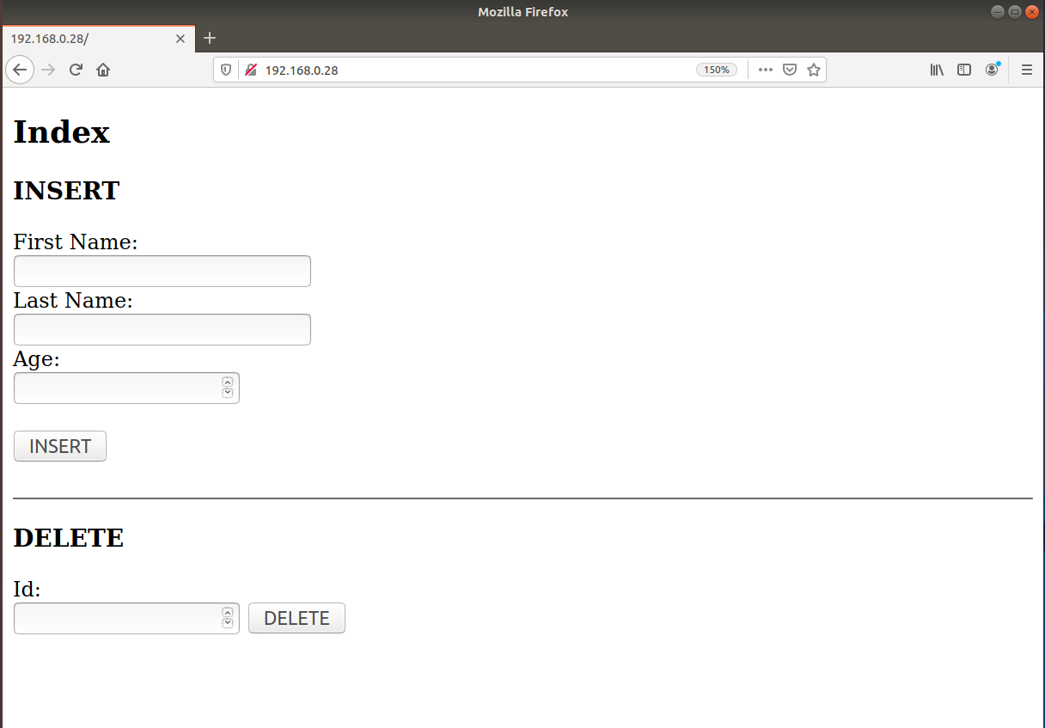

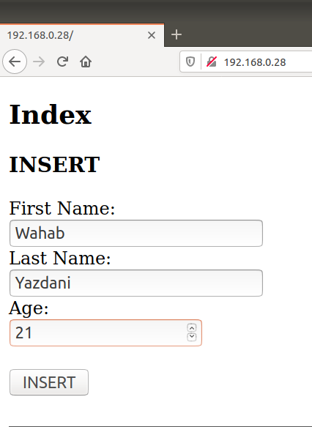

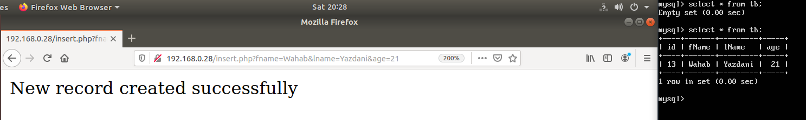

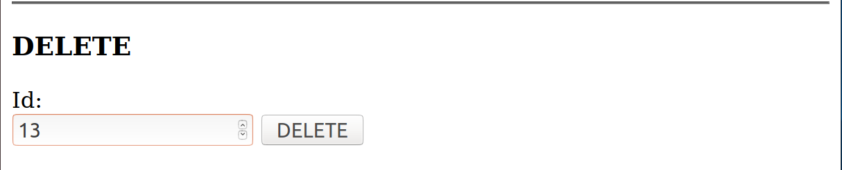

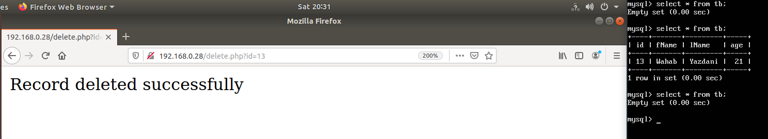

**References:**

* <https://www.w3schools.com/PHP/php_mysql_select.asp>
* <https://www.w3schools.com/PHP/php_mysql_create_table.asp>
* <https://www.w3schools.com/PHP/php_mysql_insert.asp>
* <https://www.w3schools.com/PHP/php_mysql_delete.asp>
* <https://www.w3schools.com/PHP/php_mysql_update.asp>
* <https://www.w3schools.com/php/php_forms.asp>